The Huntsville Massacre – The Civil War Forever Changes a Community

By
Joy Russell and Dr. Kevin Hatfield

Introduction

Whether or not one could refer to the events of January 10, 1863 as a massacre, one thing for sure is that the events of that fateful day would remind all that war, and its atrocities, are not limited to famous places like Antietam and Gettysburg. History quite often reserves itself to record only the big events. Many people, especially rural people, are left to believe that history and its accompanying events happen to other people in other places; that in certain respects, they are not a part of the grand scheme of things. More often than not, isolated rural people believe that their thoughts and actions do not contribute as much to the American fabric as others. To the people of Huntsville, war would leave a mark that would forever dash the dreams and visions of a small rural Arkansas community as several well known citizens, fathers, brothers, and cousins were sacrificed in the name of war. Whether or not this event fits the definition of a massacre is purely academic as that was the term most often applied to the event by the people of Huntsville. One of those who died was a trustee of the recently created Masonic college in Huntsville; one was a Baptist minister; one was a farmer and had been appointed a deputy U.S. Marshal in 1860. By some accounts, there may have been as many as nine citizens executed shortly before sunrise on a cold, frosty Saturday morning on January 10, 1863.

Most of the records and newspaper accounts of this atrocity have been destroyed or lost over time. Much of what we know is from memoirs of surviving family members, old family letters, as well as military records and journals. Some accounts were written many years after the fact and memory being what it is, we may never know exactly what happened and why. No matter what account or old letter you read, it happened and it appears that at least nine men were taken from a cold, dank guardhouse in Huntsville and led to a field on the Samuel P. Vaughn farm about 1 mile northeast of Huntsville and executed on the bank of Vaughn’s Branch near the road that led to Carrollton. Those executed on that day would include:

Chesley H. Boatright: age 39 - a blacksmith, former county treasurer, Deacon of the Huntsville Cumberland Presbyterian Church, and prominent Mason;

William Martin Berry: age 60 - a prominent member of Odeon Masonic Lodge; brother of State Senator John Berry; John Berry was also the father to James R. Berry, son-in-law of Isaac Murphy;

Hugh Samuel Berry: age 31 - son of the aforementioned William M. Berry; Capt. in the Confederate army; home on leave

John William Moody: age 32 – nephew-in-law to Chesley H. Boatright; Deputy U.S. Marshal (1860 Census Enumerator), farmer; Confederate Army Captain

Askin Hughes and John Hughes: family or military connection unknown.

Watson P. Stevens age 29; cousin of the Berry’s;

Robert Coleman Young; age 56 – also known as – “Parson Young”; Baptist Minister;

The identity of the ninth person may never be discovered. Letters belonging to the Berry Family mention the name Bill Parks as being among those arrested and shot. The name John Parks, age 32 is listed in the 1860 Madison County Census along with his wife Sarah J. and two children, Frances and William. He was born in Tennessee around 1828. The International Genealogical Index lists a John Parks having married Sarah Gillett in Winston, Mississippi on December 28, 1854. He also commanded one of the five regular Confederate companies formed in Madison County in the summer of 1862, along with John W. Moody. No other mention of his name or connection to the others has been located. His name does not appear in the 1870 census of Madison County. The recollection of Mrs. Elizabeth Vaughan mentions that the lone survivor of the massacre left for Mississippi after he had recovered from his wounds. (See page 13)

Occasionally the name William Tweedy is mentioned as being among those shot. It is possible that he may have been arrested and detained but no record can be found that he was among the men executed that day. According to Tweedy descendent Hazel Hooper, William Tweedy died from measles during the Civil War. Another descendent, Ruth Anne Nelson wrote that she had heard a family story that he had been arrested and that his wife walked to Huntsville with a feather bed for him to sleep on. Both of them would die of a contracted illness, possibly pneumonia, later on.

Besides the tragic loss of family and loved ones, this event would have far reaching affects on the community, including the demise of two early educational institutions. Had these two colleges survived, Huntsville might have been a quite different place today.

While examining the events that lead to “the massacre”, one naturally asks why the Union Army would enter Madison County and arrest so many local citizens, and then without trial or hearing, summarily execute them in violation of the 6th Article of War? (The murder of prisoners of war). What brought Isaac Murphy to Huntsville and what role did Isaac Murphy, E. D. Ham, and Col. James Johnson play? What role did Odeon Lodge and their two schools play and why did this event cause the closing of the Huntsville Institute and the Pleasant View Female Seminary? The events that lead up to that tragic day actually begin about ten years earlier, in 1854, about seven years before the Civil War begins. Here, begins our story.

The Arkansas General Assembly Incorporates
The Huntsville Masonic Institute and the
Pleasant View Female Seminary

On November 6, 1851, Odeon Lodge No. 44, Free and Accepted Masons, was chartered in Huntsville. During the Grand Lodge session of 1851, John Berry of Huntsville, also a state senator, was sent to Little Rock as the Lodge’s official delegate. During that session, much discussion was had concerning the plans for the establishment of a college in Arkansas to be sponsored by the Masonic fraternity. The formation of Saint John’s College in Little Rock would be the eventual outcome of that discussion.

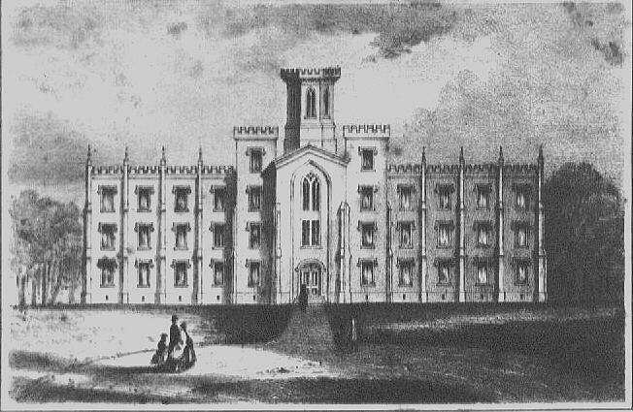

Architect’s Rendering of St. John’s College in Little Rock

As there were no higher institutions of learning in Arkansas, the idea was one of the main topics at not only that session but at sessions to come. No doubt delegate Berry reported this idea to his local lodge and the idea of creating a college in Huntsville would be discussed for the next few years as the Huntsville Lodge grew. On December 20, 1854, the Arkansas General Assembly incorporated the Huntsville Masonic Institute giving its Board of Trustees and faculty power to confer such degrees in the arts and sciences as are usually conferred in the United States. Approximately three weeks later, the General Assembly would also incorporate the Pleasant View Female Seminary at Huntsville. Although the Act referred to the school as an academy, it was known locally as a female seminary. The building was erected ¼ mile south of Huntsville on land donated by Mr. John Sanders.

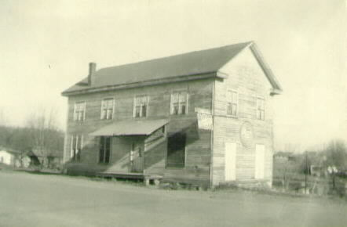

Huntsville Masonic Institute and Odeon Loge No. 44

Isaac Murphy and his family move to Huntsville

Mrs. Mary Lowe Pierson of Washington County, who appears to have been the 2nd daughter of Isaac Murphy, was hired as teacher of the seminary and Mr. Isaac Murphy and two of his other daughters were hired to assist in the running of the seminary. “Perhaps his selection of Huntsville was due to its need for teachers and his need for funds. Murphy had been the chairman of the Board of Visitors of the Far West Seminary in Fayetteville and had a great vision of public education for all citizens of the area. However, the new building for the seminary, of which he had invested not only time but money, was destroyed by fire in 1845. Mounting debts would soon cause him to travel to California in search of gold in 1849. Returning poorer than when he left, he was probably eager to accept the position in Huntsville. Records indicate that he and at least two of his eldest daughters handled the Female Seminary of Huntsville and another school.” It is assumed the other school was the Huntsville Institute as the common school which was operating in Huntsville at the time would have had no need for a school administrator.

Isaac Murphy Elected to State Senate and
Elected a delegate to Convention on Secession in 1861

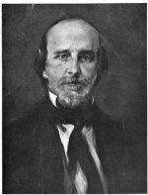

In 1856, Murphy was elected to the State Senate representing Madison and Benton counties, succeeding the deceased Senator John Berry who had sponsored the legislation creating the Huntsville Institute and the Pleasant View Female Seminary. Murphy’s connection to the Berry family would be more than political as Senator Berry’s son, James R. Berry married Murphy’s eldest daughter, Malilla.
While his service to the county as Senator was distinguished, it would be his election as a delegate to the convention on secession that would forever leave his mark on Arkansas history. In February 1861, the citizens of Madison County elected Murphy as its delegate to the convention on secession on a Unionist platform, he receiving over 85% of the vote. On March 18, 1861, the Arkansas secession convention voted 39 to 35 against secession, but then voted unanimously to put the secession question before the people of the state in an August 19th referendum. On the last day of the convention, a resolution was passed giving President David Walker of Fayetteville authority to call the convention back into session prior to the August election should “unforeseen circumstances” warrant it. Just such an unforeseen circumstance would soon manifest itself in the firing on Fort Sumter by the Confederates. Judge David Walker, the convention’s president was pressured to call the convention back into session and on May 6, 1861, he did just that. The vote on the Ordinance of Secession of Arkansas from the Union was taken without debate with only five of the seventy-five delegates voting against Arkansas seceding from the Union: Isaac Murphy of Madison County, Dr. Henry Hunter Bolinger of St. Paul (Madison County), John Campbell of Searcy County, Thomas Montague Gunter of Washington County, and Samuel Kelly of Pike County. After the vote, Convention President Walker asked the five men to change their vote to yea so that Arkansas could go out of the Union as one voice from a unanimous convention.
It is said that Murphy then stood alone saying:

I have cast my vote after mature reflection and have duly considered the consequences and I cannot conscientiously change it. I therefore vote no.

Murphy would be the lone delegate to vote “no” on Arkansas’s secession from the Union. This should have pleased the people in Huntsville, after all, most were Unionist and not in favor of Arkansas leaving the Union. Upon returning to Huntsville, he was greeted well by the locals. However, this attitude would change as the war progressed and particularly as the war came closer to home. The secession element in Madison County was growing stronger. After all, Arkansas and Madison County were now part of the Confederacy. Although a majority of the people in and around Huntsville had been Unionists, sides were now being drawn. Home guard units were organized immediately by Patrick Sanders of Huntsville and Larkin Bunch of Kingston. These units would join Col. Carroll’s regiment of General N.B. Pearce’s brigade and fight at the Battle of Wilson’s Creek near Springfield, Missouri on August 10, 1861.

War hits close to home – The Battle of Pea Ridge

On the night of March 6, 1862, Maj. Gen. Earl Van Dorn set out to outflank the Union position near Pea Ridge, dividing his army into two columns. Learning of Van Dorn's approach, the Federals marched north to meet his advance on March 7. This movement--compounded by the killing of two generals, Brig. Gen. Ben McCulloch and Brig. Gen. James McQueen McIntosh, and the capture of their ranking colonel--halted the Rebel attack. Van Dorn led a second column to meet the Federals near the Elkhorn Tavern. By nightfall, the Confederates controlled Elkhorn Tavern and the Telegraph Road. The next day, Maj. Gen. Samuel R. Curtis, having regrouped and consolidated his army, counterattacked near the tavern and, by successfully employing his artillery, slowly forced the Rebels back. Running short of ammunition, Van Dorn abandoned the battlefield. The Union controlled Missouri for the next two years.

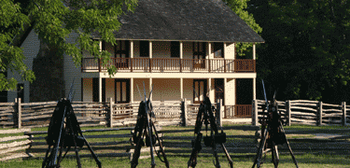

Elkhorn Tavern at Pea Ridge

Murphy’s Life is Threatened

As far as the schools were concerned, most schools closed at the start of the war and it can only be assumed that the same happened to the Huntsville Institute and the Pleasant View Female Seminary. With the war being only about 30 miles from Huntsville, the reality began to sink in locally. Assassination was hinted at and soon, private threats were once again directed at Murphy and his family. A couple of times it was rumored that mob violence might be aimed against Murphy in Huntsville but nothing apparently happened. Shortly thereafter, a public notice against Murphy was nailed to the courthouse door commanding that he and all Union forces leave Huntsville within 10 days. James R. Berry, son-in-law of Murphy, wrote on page 20 of his memoirs:

After the adjournment of the convention, he returned to his home in Huntsville, Arkansas. The country at that time had become very much excited and agitated and notice was put up at the court house for Murphy to leave the country in ten days. I went up to the crowd there where they were commenting on the notice and learning of its purport, I told them that they could not compel him to leave; if so it would have to be done over my dead body.

On the advice of friends, he shortly left home accompanied by his close friends, Dr. James M. Johnson and his brother Frank Johnson, also prominent Masons in the county. In an interview conducted by John I. Smith in 1972, Sheridan Johnson of Wesley (grandson of Dr. James M. Johnson) recalled the events of the trio’s exodus from Madison County:

Grandfather’s opinions were well known around Huntsville, and threats were made. On the day he left, he was returning from a medical call. A lady met him in the road and gave him the information that several men were in a certain home the night before, and she overheard them plot to kill him. This caused him to plan to immediately leave. He went to the Huntsville square and told he was leaving for the Union Army, but he was not bothered for his announcement. He furnished Isaac Murphy with money to send his family to Springfield, Illinois. He, Frank Johnson and Isaac Murphy left after getting the Murphy family off to Illinois. Those who planned violence followed them. About three miles west of Hindsville at Buckeye, they met a friend and told him that they were turning north toward the Union Army about thirty miles away, and that they expected soon to meet some opposition. ‘If you hear shots, do not follow us, as they will be expecting some of our friends and will shoot you also.’ They avoided contact with these men and reached General Schofield’s division of Curtis’ Army across the Missouri line.

Detachments of the Federal Army continued to camp at Elkhorn Tavern and at nearby Keitsville, Missouri, about ten miles NE of the battlefield. Murphy took a civilian position on General Curtis’s staff and would soon thereafter accompany the army on its trek to Helena in eastern Arkansas. This was in late March of 1862, He would not return to Pea Ridge until late summer of that year.

Madison County and the War

Five companies of regular Confederate troops were organized in Madison County during the summer of 1862 commanded by John W. Moody, John Parks of Bowen Township, Hiram Combs of St. Paul, Samuel Phillips of Hindsville and H.M. Moore of Kingston. In and around Huntsville, a more than usual number of Confederate guerilla bands were camping and hiding. Madison County was ideally suited as hiding grounds for these guerilla forces. It had clear spring creeks for campsites, a rugged terrain and ample farm products-grain, forage, hogs and cattle for food for the men and feed for their horses. As the main line for the Federal invasion of western Arkansas was from Springfield, Missouri through Benton, Washington, and Crawford counties to Fort Smith, opposing forces could camp in Madison County to the east of this line and strike the Federals and retreat back to their encampments. One of these guerilla bands would soon attack a Union Army escort outside of Huntsville, an event that would not be forgotten by Col. A. W. Bishop, federal commander at Elkhorn Tavern.

The Murphy Daughters Visit Their Father at Pea Ridge

Things were not going well for the Murphy daughters, Louisa and Laura at Huntsville. Their mother had died three years before in 1860, their father was a refugee with the Union Army and the locals were now harassing and scaring the daughters. By the fall of 1862, six months after leaving for Helena with the Union Army, Murphy had returned to Pea Ridge. His daughters were most eager to visit him and made the trip to Elkhorn Tavern at Pea Ridge to visit their father. No doubt they informed him of their treatment by the locals in Huntsville and one can only imagine how this made Isaac Murphy feel. On November 16th, they began their journey back to Huntsville, but for protection, Col. A. W. Bishop furnished an escort of 25 soldiers to accompany them.

Local Guerillas Attack the Murphy Escort

When the military escort and the Murphy daughters were within about two miles of Huntsville, the escort decided to send the Murphy’s on into Huntsville alone, not doubt due to the reported guerilla attacks on Union soldiers and the animosity felt by many of the locals. While the escorts rested, they were surprised by a local guerilla band and a skirmish ensued. Of the twenty five soldiers sent as escort, only seven of them would return alive to Pea Ridge.

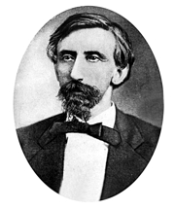
Lt. Col Albert W. Bishop

One can only imagine the anger felt by Col. Bishop, commanding officer at Pea Ridge. It was well known that at least five organized companies of Confederate soldiers were active in Madison County and it would just be a matter of time before those responsible for this attack would be found out. No doubt this event would enter into the decision of Major General John Schofield who would shortly grant authority to Col. James M. Johnson to begin raising infantry troops in the Huntsville area.

The Battle of Prairie Grove

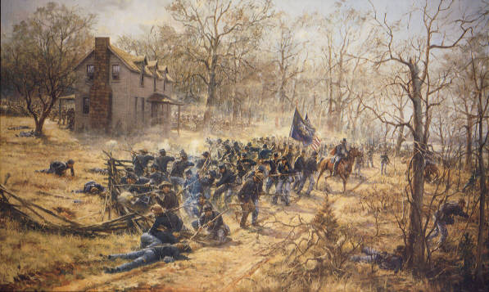

The Battle of Prairie Grove on December 7, 1862 would mark the last major Civil War engagement in northwest Arkansas. Never again would a Southern Army attempt to use the area as an avenue of invasion to Missouri. The Union armies under the command of Brig. Gen. Francis J. Herron and Brig. Gen. James G. Blunt and the Confederate forces under the command of Maj. Gen. Thomas C. Hindman, lost a total of 2,700 men who were either wounded, killed, or missing in action. While the battle was a tactical draw, it became a strategic Union victory as the Federals would maintain control of Missouri and northwest Arkansas for the remainder of the war. The remainder of the conflict in the region descended to guerrilla warfare with bushwhackers (Southern supporters) and jayhawkers (Union supporters) destroying the countryside and forcing many families to become refugees. It would take many years for the people of northwest Arkansas to recover from the effects of the Civil War.

Following this battle, the Federal strategy was then to leave General Blunt to handle the Federal cause in northeast Oklahoma and northwest Arkansas, and for General Herron to take his 5,000 troops northeast to the Mississippi to join General Grant on his push towards Vicksburg. This trek would take General Herron and his troops through Madison County via Huntsville. General Herron (who was only 25 at the time) received word of guerilla action around Huntsville. In order to clear a path for this March, he sent Lt. Col. James Stewart to Huntsville to disperse the guerillas. His report to General Herron read in part:

… on arriving [in Huntsville], I found the enemy 150 strong, had been there the night of the 18th (December), and committed depredations on all the Union families in that vicinity, more especially that of Judge Murphy (Isaac Murphy); the ladies of whose family they stripped of everything but what was on their bodies, leaving them in a destitute condition. After leaving Huntsville, some of them proceeded down War Eagle Creek, others toward Carrollton, scattering all through the country in small parties of twos and threes. I caught 15 stragglers from the rebel army and paroled them. They had all left the army immediately after the Battle of Prairie Grove.

The dispatch from Col. Stewart is interesting in that he singled out the “acts of depredation” against the Murphy daughters. This would seem to indicate that the prior acts of harassment as well as the attack and slaughter of most of the troops that had escorted the Murphy daughters back to Huntsville just a few months earlier was still on the minds of the officers who had been stationed at Pea Ridge and later deployed to Prairie Grove.

Herron’s Army Moves toward Huntsville

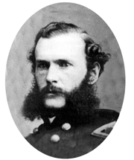
General Herron

Herron’s army would begin its march toward the Mississippi River to join Grant’s Army in his march to Vicksburg in early January, 1863. The army and staff, which included Isaac Murphy, arrived in Huntsville on January 7th. An encampment was set up in the bottoms of the Vaughn farm about 1 mile northeast of Huntsville along the road that led to Carrollton. No doubt, guerillas and other irregular Confederate forces (often referred to as bushwhackers) were constantly attacking and harassing the troops as they moved from Fayetteville via the Richland Creek area to Huntsville. It is more than likely that a few of the troops were killed as they made this journey. Herron would later write to General Schofield:

I have arrived at this place, having made but slow progress moving over these terrible roads with artillery and wagons. This country is full of bushwhackers, who annoy us very much. Our men shot one or two of them on the other side of Huntsville……

One of the Union foot soldiers, Pvt. Benjamin F. McIntyre of Iowa’s 19th Union Infantry, reported the condition of Huntsville as the army arrived:

It may have contained something over a hundred and fifty inhabitants at one time but at present it is comparatively deserted – No men at the place, a few women and Negroes are left in charge of the dwellings. . . The town has but few fine dwellings and a few storehouses which would be an ornament to any place – they have all the modern improvements for business houses and are calculated to contain a very extensive stock of goods . . .

Besides foraging the area for food and other supplies, the Union soldiers set about rounding up several local citizens in and around the Huntsville area. Lizzie J. Mitchell, a grand niece of William M. Berry wrote in her memoirs from her home in Los Angeles in 1914-1915 the following:

“… some of the men from Huntsville, officers of the blue uniform, came out and told these old men to come to Huntsville and take the oath of allegiance. Their wives did not want them to go but thought if they could stay at home and save what little was left, it would be better.”….

During the Civil War, political prisoners and prisoners of war were often released upon taking an "oath of allegiance". For many, being forced to take an oath of allegiance in order to obtain release was nothing more than another form of harassment. Not only was it general harassment and degrading to the individual, it had moral and ethical implications for the proud Ozark people. Taking such an oath just in order to save one’s self was much like being a traitor. There were many different forms of the oath of allegiance used in the area. Some were quite simple and easily understood by the locals while some forms of the oath were much longer and not as easily understood by those with a limited education.

Oath of Allegiance

I, ________________, do solemnly swear or affirm, in the presence of Almighty God, that I will henceforth faithfully support and defend the Constitution of the United States and the Union of the States there under.

Signed: ______________________________

Oath of Allegiance

I do hereby solemnly and sincerely swear, in the presence of Almighty God, that I will support, protect, and defend the Constitution and Government of the United States against all enemies, whether domestic or foreign, and that I will bear true and faithful allegiance and loyalty to the same—any ordinance, resolution, or law of any State, Convention, or Legislature to the contrary notwithstanding; and further, that I take this oath, and assume all its responsibilities, legal and moral, of my own free-will, and with a full determination, pledge, and purpose to observe and fulfill it, and without any mental reservation or evasion whatever; and, further, that I will well and faithfully perform all the duties that may be required of me by law, as a true and loyal citizen of the United States. And may God help me so to do!

Signed: ________________________

Local Citizens Arrested

It was common place to round up locals and bring them to the county seat or other place to administer the oath publicly or have the person sign a copy of it before witnesses, which was even more degrading. In some cases, the locals were immediately released and sometimes they were held in a stockade or other guardhouse for a time. It was soon to become apparent to the captives and their families that someone in Huntsville had identified these men to the soldiers as being a part of the guerilla group that had killed the union escort two months ago and were probably responsible for the harassment and acts of depredation against the Murphy sisters. It is also possible that those being arrested were simply being identified as southern sympathizers or possible leaders among the small bands of bushwhackers.

“Uncle Chesley Boatright went to town (Huntsville) for a purchase of some kind and taken while in town. As he left the house, his father, William B. Boatright, [age 85] asked to let him go instead of Chesley. He told Chesley that he might be caught by the “bushwhackers”, [he probably meant jayhawkers or union troops] but Uncle Chesley told his father that he did not fear them because he was too old to go into service. (Chesley was 39 years old at the time.)

Hugh Berry had just been home a few weeks, on leave or furlough from the Confederate army due to illness. He had probably fought at the Battle or Prairie Grove. J. W. Moody was with him. Shortly after the arrival of federal troops in the area, soldiers arrested Hugh Berry, John W. Moody, Chesley Boatright and William M. Berry. William Berry, being age 60, was left at home for the time being but the others were taken to Huntsville and incarcerated. Isaac Murphy and E. D. Ham had returned to Huntsville with General Herron’s troops. Whether in person or by order, they had William Berry, who had been left at home a few days before, also brought to Huntsville. Mrs. Nancy Berry, wife of Hugh Berry, would visit with her husband at the stockade shortly thereafter. There she would see Col. James Johnson, Isaac Murphy, and E. D. Ham. Col. Johnson apparently obtained a pass for his brother Frank Johnson to escort her outside of the pickets. Once outside, Frank would confide to Mrs. Berry that he felt that there was something wrong, no doubt fearing for the men’s lives. It is not known exactly what information Frank Johnson was privy to and why his communication with Nancy Berry seemed to be a warning of things to come. On Wednesday, January 7th, Hugh Berry was granted a “parole of honor” to go home for a few days. It appears he was to return to Huntsville on Friday. Col. James M. Johnson apparently made a trip to visit Hugh Berry at his home on Thursday or Friday evening. Upon his arrival, Hugh was visiting his father William at his home. Nancy Berry and Col. Johnson then went to the home of William Berry where all had supper together. At one point during supper, Hugh expressed his concern about being a prisoner of war and may have expressed thoughts of violating his parole of honor but was urged by Col. Johnson not to do so and return to the stockade as he had promised. According to Nancy Berry, Hugh and William would return to town early on Saturday.

In the early morning hours of January 10, 1864, Chesley H. Boatright, William Martin Berry, Hugh Samuel Berry, John William Moody, Askin Hughes, John Hughes, Watson P. Stevens, Robert Coleman Young, and possibly John Parks were marched to a spot along Vaughn’s branch at the encampment. William V. Polk who was arrested the day before on January 9th, stated that about 4:00 a.m. on the morning of January 10th, Robert Young, Hugh Berry, Billy Berry, Chesley Boatright and others were led out so close to me that they brushed my clothing as they passed by”. Lt. Col. Elias Briggs Baldwin, commander of the 8th Missouri Calvary, Volunteers, Union army gave the order to have the men executed. Sgt. Thomas B. Payne of Company G was in charge of the firing squad. Just a few hundred yards from the road on the banks of Vaughn’s branch, the prisoners, with hands tied and blindfolded, were shot by the firing squad.

There are three accounts recorded of locals becoming involved in the event after the shooting. The first account is that of Mrs. Elizabeth Vaughn, the widow of Samuel P. Vaughan, whose home was about a quarter of mile west of the spot where the execution occurred. According to Mrs. Vaughn, one of the men was not mortally wounded by the firing squad, but lay silently on the cold ground. If the massacre occurred shortly after 4:00 a.m. as told by William Polk, it was still quite dark and it would have been possible for the members of the firing squad to have not been able to ascertain if all were actually dead. The men were apparently left for dead along the branch. It would be up to family members to come and claim the remains. Mrs. Vaughn told that this unknown prisoner had been shot in the head with the shot knocking our some of his teeth. The wounded soldier then crawled up the branch to the Vaughn home where he begged for help. Mrs. Vaughn would house the injured man and nurse him back to health for the next month. When he was able, she stated that he left for Mississippi. She could not remember his name but stated that he came back years later for a short time to simply visit the site where the tragedy had occurred. After this visit, he was never heard from again. This may have been John Parks, previously referred to.

The second account is from the memoirs of Lizzie J. Mitchell, grand niece of William Berry, who wrote that a Mary McRunnells. (this is no doubt Mary Elizabeth McReynolds, wife of Isaac D. McReynolds who apparently had a farm adjacent to or near the Vaughn farm. There are no records of a McRunnels family in the area and local genealogists agree that the name McReynolds was quite often pronounced as McRunnells by the locals and spelled phonetically as such) went to see if she knew any of the men who had been shot. According to her story, all but one of the men at the scene was dead. The prisoner referred to by Mrs. Vaughn would have already crawled from the scene and would be at the Vaughn home by this time. She then took a hat, dipped it into the cold stream to get water to bathe the lone survivors’ face. She recognized him as young Hugh Berry. As soon as possible, she sent word to the Berry family to inform them of what had just transpired. Later in the day, Nancy Berry, “old lady Berry” [Margaret Berry, wife of William] and one of her sons would arrive at the scene where they would find Hugh still alive. It is hard to imagine what a difficult circumstance this must have been for all of the women involved. News of the execution must have spread like wild fire throughout the community. Many of the families had left days before the federal troops moved into Huntsville. With so many of the men being rounded up for questioning and with so many arrests taking place, few men remained in the area and it was up to the women and their younger sons to deal with this horrible tragedy. Hugh was transported back home where he told what had happened to his wife.

“…Hugh, who did this? He said men out of the 8th Missouri Regiment did the shooting, but J. M. Johnson, E. D. Ham, and Isaac Murphy had it done. He also told the same to several others before he died on January 13, 1863. The day before he died, some Federal officers together with a doctor, came out and dressed his wounds and took his dying testimony. He told them the same thing, that Johnson, Ham, and Murphy had it done and the officers wrote down his testimony.”

The third account is from Annie Boatright Champlin, granddaughter of Chesley Boatright as told to Ann Marie Boatright Ryals and Connie L. Moore, granddaughter of Sarilda Boatright Hale. On receiving word of the executions, Chesley’s wife Drusilla, her young son John along with Sarilda Boatright Hale and Tennessee Boatright Bowen, both sisters to Chesley, drove a wagon to the site of the murder and brought Chesley Boatright’s and J. W. Moody’s bodies home to prepare the remains for burial and later buried them in their family plots in the Huntsville Cemetery. John Boatright, later known as “Preacher John” said it was a sight that he would never forget although he was only 4 years old at the time.
Troops Begin to Leave Huntsville

During the next week, the encampment began to break up with columns and detachments leaving at different times. The execution must have had a chilling effect on the people of Huntsville as many were reporting to officers at the encampment requesting protection and now wishing to take the oath of allegiance. News of the execution of the prisoners was also spreading among the union troops. Pvt. Benjamin F. McIntyre of Iowa’s 19th Union Infantry, wrote on January 20th in his diary:

I learned that after our departure . . . seven rebels were shot by order of Major Baldwin. I hope this may prove incorrect for it is establishing a precedent which must end in rapine and murder and is giving the butternuts an excuse to put to death every Union man that should fall into their hands.
Rapine is the act of plundering or the seizing and carrying away of another's property by force. Northern soldiers called Confederates "butternuts" because of the tan-grey color of the uniforms.
The division remained in Huntsville until January 18th, the troops suffering under a more than ordinary complication of all the discomforts and ills incident to a winter campaign. Sometimes on half rations – occasionally on quarter rations, and frequently with no rations at all – harassed with orders to move each morning, which were as often countermanded in the evening after remaining all day exposed to the rain without shelter, with our wagons loaded ready to move. The rain which had been falling incessantly for several days was succeeded by a snow storm, which added to the great scarcity of rations, increased the discomfort to such an extent that men grew indignant at the tender-footed policy of the General in regard to “respecting private property”, and commenced pillaging from the inhabitants in order to prevent starvation among themselves. This state of affairs culminated on the 16th in some bold an successful attempts a robbery in the town [Huntsville] which induced Gen. Schofield to order another move, notwithstanding the almost impassable condition of the roads. Accordingly, our brigade left Huntsville on the morning of the 18th …
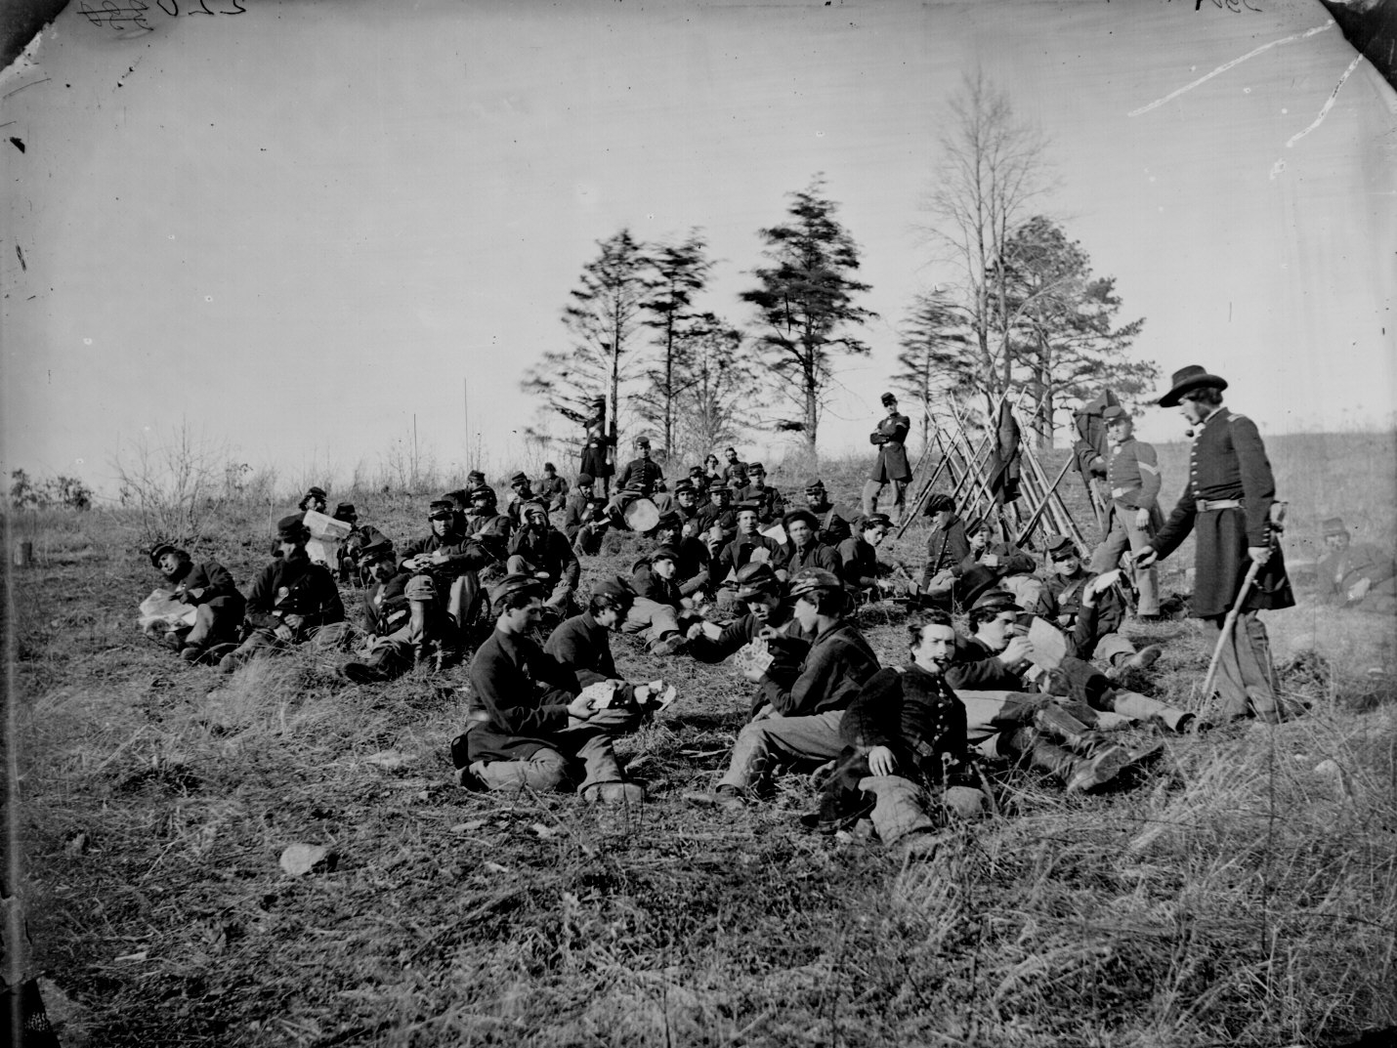
A Civil Scene as it might have been near Huntsville
News of the Shooting Spreads: Baldwin Arrested and Charged
Even as the troops left Huntsville, there is no doubt that the execution of the prisoners was on the mind of those who were aware of it. On January 25th, a letter from Col. James O. Gower, commander of the 3rd division of the 1st Iowa Cavalry, was written to Col. C. W. Marsh, assistant adjutant general. In this dispatch, Col. Gower wrote:
“I have called upon Lt. Col. Baldwin, provost marshal of the division, to furnish a written statement of what disposition was made of nine prisoners of war (referred to in Col. Dan Huston’s letter) supposed to have been murdered at Huntsville, Ark. on the 10th instant and will report as soon as the matter can be investigated. I have no doubt that some officer of this division ordered these men shot, and regard it myself as a great outrage.”
Any official report from Lt. Col. Baldwin and the letter from Col. Dan Huston referred to in Col. Gower’s letter was never found in any governmental record or Civil War journal. It can only be assumed that the letter from Col. Huston gave a detailed account of what happened in Huntsville.
Lt. Col. Baldwin was only 28 years old and had been promoted to the provost position on January 7, 1863, three days before the murder of the prisoners. His orders at Huntsville were to keep the soldiers in line, keep the infantry off their horses, and prevent the soldier’s from plundering, shooting, or otherwise violating direct orders and the general orders of General Schofield concerning respecting the rights and property of the locals. This being his orders, it is difficult to understand what circumstances would have lead him to order the firing squad to execute the prisoners.
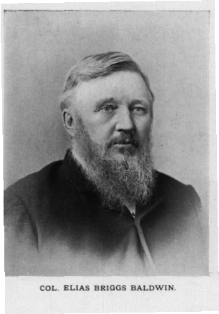
Lt. Col. Baldwin resigned his commission two days later, on January 27th when an order was issued for his arrest in connection with this crime. He would be formally arrested by Col. Gower when he reached Forsythe, Missouri, on January 29th. He was then transported to Springfield, Missouri where he was to be held pending a trial before a military commission consisting of General J. M. Schofield, Thomas Ewing, Jr., W. M. Hubbard, and another individual whose name was not legible in the official record. The charge against Baldwin was
“violation of the 6th Article of War or for the murder of prisoners of war, C.H. Boatright, W. M. Berry, Hugh Berry, Askin Hughes, John Hughes, Watson Stevens, J. W. Moody, and Young, called Parson Young; “this before the Chesley Boatright, et. al., had been tried, convicted, and sentenced to death by the legally constituted authority of the United States.”
John I. Smith in his article The Gravestones Bear Witness which appeared in the Northwest Arkansas Times in September, 1974, wrote:
“Baldwin was also charged with contempt and disrespect toward his commanding officer for failing to comply with a written request from Col. James O. Gower, dated January 24, 1863, ordering him to send a written statement as to what disposition was made of certain persons turned over to him as Provost Marshall.
Baldwin did not go with his soldiers to the shootings. Instead, they were sent under Sergeant Payne who, during his defense fell back on his orders from Baldwin. Baldwin’s defense was simple. That whatever was done, was done with the knowledge and consent of the general commanding and others then and there present and not on his part. He asked that others then far way in southeast Missouri, and elsewhere, including General Herron and Isaac Murphy, be brought back as his defense witnesses.
It is easy to see why General Herron would be called as a defense witness but it is not as easily discernable why Lt. Col. Baldwin would need Isaac Murphy to appear on his behalf. This implies that Isaac Murphy had more information about the execution than had generally been thought. General Herron had become seriously ill during the rapid movement of his army toward the Mississippi to join General Grant and was unable to attend the court martial. Isaac Murphy was in St. Louis tending to the illness of his two daughters, Louisa and Laura, and also was not able to answer the summons to appear. Col. F. M. Sams and Mrs. Elizabeth Vaughan also appeared before the tribunal. Exactly what information they furnished to the proceedings is not clear, but it appears that they were providing information that would substantiate that those shot were indeed part of a guerilla band and that E. D. Ham was not directly involved in the shootings.
Since General Herron and Murphy could not attend and other witnesses for the defense could not be present, Lt. Col. Baldwin was not further tried. He was given an honorable discharge on June 24, 1863 and granted transportation back to his home in Young America, Illinois. This would officially close the investigation concerning what was becoming known around Madison County as the Huntsville Massacre.
The Aftermath of War and the Massacre
Be there no doubt, Huntsville and Madison County suffered from the war, especially in 1863. After federal troops moved through Madison County in January 1863, large scale foraging and looting took place in Huntsville and the surrounding farms. The families who decided to stay, no doubt had a rough time surviving. Not only would they suffer from the pain of poverty, hunger, and the other ravages of war, but they also suffered a psychological pain that accompanied their knowledge of the executions and especially that darker knowledge that one of their own neighbors or acquaintances had betrayed them. No one came out of this as a winner: Not Col. Baldwin, not Isaac Murphy, and not the local guerilla bands and other southern sympathizers. Most lost beloved family members and friends; some would fight for a time to recover their social standing; the community would lose several great institutions; trust among neighbors would take time to regain; some could never forget or forgive. For the next 80 years, children would bring flowers and mussel shells to the site in order to memorialize it. These collective actions can destroy a community as easily as a natural disaster. It almost did.
Many people believed that the massacre occurred in retaliation for the loss of the 18 soldiers that were ambushed while escorting the Murphy sisters back to Huntsville. The continued harassment and mistreatment by local southern sympathizers of the Murphy family certainly makes a strong case for this theory. Hugh Berry’s final account of the massacre names Isaac Murphy, Col. James Johnson and E. D. Ham has those responsible for the executions.
Isaac Murphy left Huntsville with Herron’s army and would leave the army in Springfield, Missouri where he would travel on to St. Louis. After the Huntsville massacre, the harassment of his daughters continued and a Federal detachment came back to Huntsville where they transported the daughters to a railroad depot near Rolla, Missouri, traveling on to St. Louis to be with their father. The weather was extremely cold and wet and three of the children, Louisa, Laura and Willie Lowe, four year old son of Mary Murphy Lowe, would die shortly thereafter in St. Louis, probably of pneumonia and exposure, due to the long cold trip to St. Louis. Louisa was 24 years old and Laura was 22. Murphy would become the 8th Governor of Arkansas (1864 -1868), the first after the Civil War. He would die after a short illness in Huntsville on September 8, 1882.
Col. James. M. Johnson would be elected to Congress in 1864 and 1866, representing the 3rd Congressional district of Arkansas but never took his seat. Arkansas had no congressional delegation seated during those years. In 1867, he was elected as lieutenant governor of Arkansas and served in that position for two years. He would afterwards be appointed as Secretary of State and would serve in that position for about five years. He also served on the early board of trustees of the University of Arkansas and by some, touted as being responsible for the location of the University at Fayetteville.
Elijah D. Ham, age 25, lawyer, Major in the First Arkansas Infantry with Col. Johnson, once was described “as the meanest man in Madison County” . Years following the Huntsville Massacre, many people felt that he was the central figure in pointing out locals to the federal troops. “There is evidence to prove that one E. D. Ham who was bitter against some of these men shot, instigated the whole matter, since he told on the night before the shooting in the morning that they would be killed. He had this talk, as it is charged, 10 miles west of Huntsville.” There are some who imagine Ham held a bitter grudge against several of the prisoners possibly over having been blackballed by the Masonic Lodge. E. D. Ham would hold many public offices in years to come that include: state senator (1864 – 1866) District Attorney, 1866, circuit judge (1868-1873).
Chesley H. Boatright was born May 10, 1824 in Grainger County, Tennessee. He was a blacksmith, former county treasurer (1854 – 1856), Deacon of the Huntsville Cumberland Presbyterian Church, and prominent Mason and member of Odeon Lodge No. 44. He and his wife Drusilla are buried in the Huntsville Cemetery. It was told that Chesley’s son, John Chesley Boatright learned that years later Col. James M. Johnson had been invited as a guest speaker for a local reunion of Union soldiers. John Chesley sent word to Col. Johnson that if he made an appearance at the reunion, he would kill him. The story went on to say that Johnson did not attend the reunion. The story certainly demonstrates that the Boatright family felt that Col. Johnson was involved and was a responsible party in the death of Chesley Boatright.

William Martin Berry, age 60 at the time of the massacre was a prominent member of Odeon Masonic Lodge and brother of State Senator John Berry. William Berry had a minor connection to Isaac Murphy in that his brother, John Berry, was the father of James R. Berry, son-in-law of Isaac Murphy; William Berry is buried at the Alabam Cemetery

Hugh Samuel Berry, age 31 was born September 10, 1831 in Alabama and married Nancy Margaret Tucker. He was the son of the aforementioned William M. Berry and was a Capt. in Company A of the 4th Arkansas State Infantry. He was home on leave due to illness at the time of the execution. He had four small children at the time and is buried in the Alabam Cemetery.

John William Moody, age 32 was a nephew-in-law to Chesley H. Boatright. He was appointed as a Deputy U.S. Marshal for the purpose of enumerating the 1860 Census. He was a farmer and a Confederate Army Captain. His wife, Mary Elizabeth Waits Moody would give birth to a baby girl, a few weeks later. She would name her Johnnie. He is said to be buried in the Huntsville Cemetery with a headstone with no markings.

Askin Hughes and John Hughes: no family or military connection to the others executed has been found. They were believed to have been residents of Washington County and are thought to be buried at the site. They may have been members of one of the five confederate companies formed in the summer of 1862.

Watson P. Stevens, age 29 was a cousin of the Berry’s. He is thought to be buried at the site.

Robert Coleman Young, age 56 was also known as “Parson Young”. He was born August 23, 1804 in South Carolina and was a Baptist Minister. He was buried at the Harris Farm Gravesite, 3 miles south of Huntsville. It is not known why he is buried at this location since his family lived near Hindsville at the time of his death. As the men were left as dead, his burial there may have been as a matter of convenience by someone who knew him well.
Lt. Col. Elias Briggs (E. B.) Baldwin – Following his honorable discharge from the army in 1863, he moved to Illinois for about a year. Due to ill health, he and his wife moved to Clinton County, Iowa where he resided until 1868. He would later move to Kansas where he served two terms as County Clerk of Labette County. He would retire to his home near Edna, Kansas. He died at Oswego, Kansas in 1921.
Odeon Lodge No. 44
Although it is not entirely clear what happened, a catastrophe of sorts hit the lodge in 1869. It appears that three of the founding members who were also past masters of the Lodge were tried before the Lodge. Presumably, the charges centered on events related to the Huntsville massacre although this cannot be fully substantiated. The three members, Samuel Kenner, J.S. Polk, and John Vaughn were found guilty of Un-Masonic conduct and were expelled from membership by the lodge. The exact specifications of the charges of Un-Masonic conduct were not spelled out in the proceedings of the Grand Lodge of Arkansas. The resulting trial and expulsion of the three members destroyed the fellowship and brotherhood of the lodge and it rarely met after the trial of the three brothers. In 1875, the Grand Master of Masons in Arkansas ordered the Lodge closed. The two schools sponsored by this Lodge would also close as a result. Later, it would be determined that the trial by the Lodge was not proper and the charges against the brothers deemed inappropriate. Two years later, the members petitioned the Grand Master for a dispensation to create a new lodge in Huntsville. Apparently, the members decided it was best not to assume their old name and number, which they could have done, and started with a whole new identity, Huntsville Lodge No. 364.
Afterword
Be there no doubt, a lot of people did a lot of talking about this event following the Civil War. Much of it was done in private conversations, some were written years later in reminiscences’ about the times, and some accounts were given in public letters to local newspapers. Those written accounts quite often contain verifiable errors in names and dates. One of the most interesting omissions about this event is its noticeable absence in the Goodspeed Biographical and Historical Memoirs of Northwest Arkansas, published in 1889. Even though seven pages were dedicated to Civil War events in Madison County, no mention is made of the massacre. The story of the ambush of the military escort of the Murphy daughters is included. Why this particular event would not have been mentioned is quite an enigma.
This version of the account raises more questions than can be answered in this version of the massacre. If Col. James M. Johnson was a central figure in the arrest of these men, one wonders why he would have had dinner with one of the men just prior to his execution. Why would Hugh Berry be given a parole to go home just before his execution? Why would Frank Johnson give Nancy Berry a warning that something was wrong and why did Col. Johnson arrange for the pass outside of the pickets? Why would a young lawyer (E. D. Ham), just 25 years of age be so involved in this event and how could one be considered the “meanest man in Madison County” at so young of age, then elected to so many public offices, two of which voters in Madison County cast ballots? Did those Masons tried in their local Lodge have information relative to this massacre that surfaced a few years later? Was the trial actually related to the executions? No firm evidence was ever produced that linked Isaac Murphy, James Johnson and E. D. Ham to the event.
This is by no means the definitive account of the Huntsville Massacre. This is written at this time because of the dedication of the monument at the site where the massacre occurred. A few years before his death, Mr. Bill Coleman, owner of the old Vaughn farm, pointed out the exact spot where the massacre occurred to members of the historical society and Huntsville Lodge. When he purchased the farm, a small fence and lots of mussel shells surrounded the site. Over time, his cattle torn down the fence and the shells gradually disappeared.
As far as new and updated information about the Huntsville Massacre is concerned, perhaps other family letters and records not yet known may provide more information surrounding the events and people involved. Perhaps enhanced computer access to governmental and genealogical records may provide new information heretofore not accessible. Perhaps this is all that we will ever know.

Ryals, Ann Marie Boatright, Discussion forum, Retrieved 5/22/2003 from http://archiver.rootsweb.com/th/read/ARMADISO/1999-06/0928364555/
Berry, James R., Memoirs of J. R. Berry, p. 24.
Smith, John I., 1974, (September 15), The Gravestones Bear Witness. Northwest Arkansas Times, pp.B1, B2
Ibid., p B1
Berry family letters written in 1931 in possession of Nancy Barnett, Westminster, Colorado.
Nelson, Ruth Ann and Wiley, Jeannine, Discussion forum, retrieved 6/2/1999 from http://archiver.rootsweb.com/th/read/ARMADISO/1999-06/0928381320
Hatfield, Kevin, The Masonic Lodges of Madison County, Arkansas, Madison Co. Musings, Vol. 13, Summer 1994, pp. 66 – 67.
Acts of Arkansas (1854), 63-63.
Acts of Arkansas (1855), 108-109.
The History of Northwest Arkansas (New York: Goodspeed Publishing Company, 1889), 421.
Smith, John I., The Courage of a Southern Unionist, (Little Rock: Rose Publishing Company, 1979), p. 13.
Ibid., p. 12
Ibid., p. 21.
Epperson, J.F., Chronology of the Fort Sumter Crisis, Retrieved August 30, 2006 from http://members.aol.com/jfepperson/sumter.html
Smith, op. cit., p. 33.
Publication of the Arkansas Historical Commission, 1906, Vol. I, p. 306 – 312.
Missouri in the Civil War Vol. 9, Chapter VI Confederate Military History Retrieved August 28, 2006 from http://www.civilwarhome.com/missouri6.htm
The Battle of Pea Ridge (Elkhorn Tavern) March 7-8, 1862 Retrieved August 30, 2006, from http://www.civilwarhome.com/pearidge.htm
Smith, op. cit, p. 42.
The History of Northwest Arkansas, op. cit.
Smith, John I., 1974, (September 8) The Huntsville Massacre, Northwest Arkansas Times as reprinted in Madison County Musings, Vol. 13, No. 2.
Smith, John I., The Courage of a Southern Unionist, (Little Rock: Rose Publishing Company, 1979), p. 42.
Ibid., p. 42.
The History of Northwest Arkansas, op. cit.
Montgomery, Don, The Battle of Prairie Grove, Heritage Trail, Retrieved August 30, 2006 from http://www.heritagetrailpartners.com/pi_prairie_grove.html
United States War Department, The war of the rebellion: a compilation of the official records of the Union and Confederate armies. / Series 1 - Volume 22 (Part I), p. 165.
Smith, 1974 (September 8), op.cit.
Tillie, Nannie M., ed., Federals on the Frontier: The Diary of Benjamin F. Mc-Intyre, (Austin: 1963)
Wikipedia Encyclopedia, retrieved September 3, 2006 from http://en.wikipedia.org/wiki/Loyalty_oath
Berry, Nancy, Letter to the Editor of the Madison County Democrat, August 11, 1890, reprinted in Fading Memories II, 1992, p. 69.
Ibid, p. 69.
Ibid., p 69.
Affidavit of William V. Polk, sworn before County Clerk John A. Bunch on August 11, 1890.
Waits, Wally, Massacre at Huntsville, Madison County Musings, Vol. II, Spring 1983, p. 4
Smith, John I. Sept. 15, 1974, Northwest Arkansas Times, op. cit.
Mitchell, Lizzie J., personal memoirs,
Berry, Nancy, op. cit.
Berry Nancy, op. cit.
Chancey, Floy Bess, Old William Boatright and His Descendents, family history, p. 68.
Ryals, op. cit. and Chancey, ibid., p. 68
Tillie, Nannie M., op. cit.
Tillie, Nannie M., op. cit.
Barney, Capt. C, Recollections of Field Service with the 20th Iowa Infantry Volunteers, Davenport, IA, 1865.
United States War Department, The war of the rebellion: a compilation of the official records of the Union and Confederate armies. / Series 1 - Volume 22 (Part I), p. 74.
Smith, John I. Sept. 15, 1974, Northwest Arkansas Times, op. cit.
Smith, Ibid.
Madison County Musings, Volume 13, Summer 1994, Letter from E. D. Ham to A.M. Wilson, p. 85.
Smith, John I., The Courage of a Southern Unionist, (Little Rock: Rose Publishing Company, 1979), p. 43.
Ibid., p. 144.
The History of Northwest Arkansas (New York: Goodspeed Publishing Company, 1889), p. 1098.
Letter from D.D. Sanders, Madison County Musings, Volume 13, Summer 1994, p. 77.
Berry, James R., Memoirs of J. R. Berry, p. 24.
Berry, Fred T., Dear Cousin, A History of the Berry Family, pp. 107 – 110.
Ryals, Ann Marie Boatright, Discussion forum, Retrieved 5/22/2003 from http://archiver.rootsweb.com/th/read/ARMADISO/1999-06/0928364555/
Ibid., p B1
Hatfield, Kevin, The Masonic Lodges of Madison County, 1994.

